**INTRODUCTION TO RELATIONAL & LOGICAL OPERATORS**

**AND INTRO OF IF CONDITIONAL STATEMENT**

**LAB # 3**



**Spring 2019**

**CSE102L Computer Programming Lab**

Submitted by: **SHAH RAZA**

Registration No. : **18PWCSE1658**

Class Section: **B**

“On my honor, as student of University of Engineering and Technology, I have neither given nor received unauthorized assistance on this academic work.”

Student Signature: ______________

Submitted to:

**Engr. Madiha Sher**

March 3, 2019

Department of Computer Systems Engineering

University of Engineering and Technology, Peshawar

## Objectives:

* To be familiar with Relational & Logical Operators
* To understand the programming knowledge using Decision Statements (if, if-else, if-else ladder, Nested if-else)

**TASK # 1:**

**Title:**

Display the largest among three numbers using if else statement.

**Code:**

#include <iostream> /* library for

writing the output to console window*/

using namespace std;

int main()

{

//Variable Declaration

int A,B,C;

cout << "Enter the value of A: ";

//Input value of A

cin>>A;

cout << "Enter the value of B: ";

//Input value of B

cin>>B;

cout << "Enter the value of C: ";

//Input value of C

cin>>C;

//White spacing

cout<<"\n\n";

//When A is the greatest number

if (A>B && A>C)

cout<<"A is the greatest number";

//When B is the greatest number

else if (B>A && B>C)

cout<< "B is the greatest number";

//When C is the greatest number

else if (C>A && C>B)

cout << "C is the greatest number";

//When A and B are equal and greatest

else if (A==B && A>C)

cout << "A and B are equal and greatest";

//When A and C are equal and greatest

else if (A==C && A>B)

cout << "A and C are equal and greatest";

//When B and C are equal and greatest

else if (B==C && B>A)

cout << "B and C are equal and greatest";

//When A,B and C have equal values

else

cout << "All values are equal";

return 0;

}

### **Output (Compilation, Debugging & Testing):**

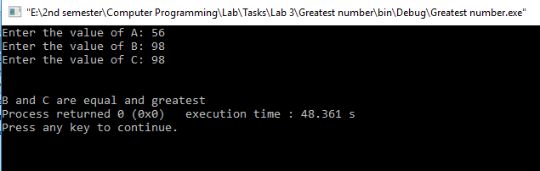

**TASK # 2:**

**Title:**

Check whether a number is even or odd using ternary operator.

**Code:**

#include <iostream> /* library for

writing the output to console window*/

using namespace std;

int main()

{

//Variable declaration

int num;

cout << "Enter the number: ";

//Input value of num

cin>>num;

//One line space

cout<<"\n";

//Determining even or odd using ternary operator

(num%2==0)? (cout << "This is an even number"):(cout<<"This is an odd number");

return 0;

}

### **Output (Compilation, Debugging & Testing):**

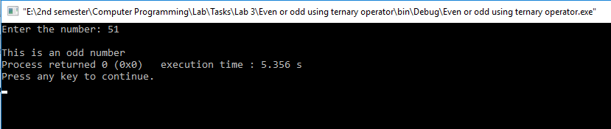

**TASK # 3:**

**Title:**

Check the greater of two numbers using ternary operator.

**Code:**

#include <iostream> /* library for

writing the output to console window*/

using namespace std;

int main()

{

//Variable declaration

int A,B;

cout << "Enter the value of A: ";

//Input value of A

cin>>A;

cout << "Enter the value of B: ";

//Input value of B

cin>>B;

//One line space

cout<<"\n";

//Finding greatest number using ternary operator

(A>B)?(cout<<"A is greater than B"):((B>A)?(cout<<"B is greater than A"):(cout<<"Both are Equal"));

return 0;

}

### **Output (Compilation, Debugging & Testing):**

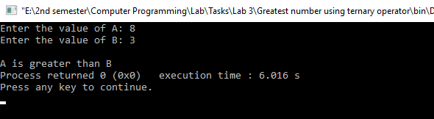

**TASK # 4:**

**Title:**

Write a MarksSheet program, input 5 subject marks from user and show data on screen, with percentage, grade and average marks (Assume total marks = 100).

**Code:**

#include <iostream> /* library for

writing the output to console window*/

using namespace std;

int main()

{

cout << "\t\tMarks Sheet:" << endl;

//Variable declaration

int A,B,C,D,E,sum;

float Percentage,Average;

cout<<"Marks in Computer Programming: ";

//Input value of A

cin>>A;

cout<<"Marks in English: ";

//Input value of B

cin>>B;

cout<<"Marks in Deferential Equation: ";

//Input value of C

cin>>C;

cout<<"Marks in Circuit and Systems: ";

//Input value of D

cin>>D;

cout<<"Marks in Pakistan Studies: ";

//Input value of E

cin>>E;

//Two line space

cout<<"\n\n";

//Formula for sum

sum = A+B+C+D+E;

//Formula for Percentage

Percentage = (sum*100)/100;

//Formula for Average

Average = sum/5;

//When total marks are greater than 100

if (sum>100)

{ cout<<"Wrong Entries";

}

//When marks are less than or equal to 100

else

{

//Display Percentage

cout<<"Percentage: "<<Percentage<<"\t";

//Display Average

cout<<"Average: "<<Average<<"\t";

//When marks are greater than or equal to 95

if(sum>=95)

cout<<"Grade: A";

//When marks are greater than or equal to 90

else if(sum>=90)

cout<<"Grade: B";

//When marks are greater than or equal to 85

else if(sum>=85)

cout<<"Grade: C";

//When marks are greater than or equal to 80

else if(sum>=80)

cout<<"Grade: D";

//When marks are greater than or equal to 65

else if(sum>=65)

cout<<"Grade: E";

//When marks are less than 65

else

cout<<"Grade: F";

}

return 0;

}

### **Output (Compilation, Debugging & Testing):**

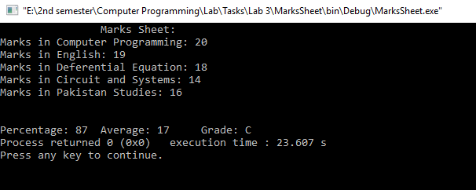

**TASK # 5:**

**Title:**

Write a C++ program that takes two operands and one operator from the user, the program should implement basic arithmetic operations – sum, average, product, difference, quotient, remainder, and, or and not of given numbers etc.

**Code:**

#include <iostream> /* library for

writing the output to console window*/

using namespace std;

int main()

{

//Variable declaration

int A,B,sum,diff,prod,remainder,AND,OR,NOT_a,NOT_b;

float quotient,avg;

char OP;

cout << "Operand1: ";

//Input value of A

cin>>A;

cout << "Operator: ";

//Input value of OP

cin>>OP;

cout << "Operand2: ";

//Input value of B

cin>>B;

//Sum

sum=A+B;

//Difference

diff=A-B;

//Product

prod=A*B;

//Remainder

remainder=A%B;

//Division

quotient=A/B;

//Average

avg=sum/2;

//Bitwise AND

AND=A&B;

//Bitwise OR

OR=A|B;

//Bitwise NOT

NOT_a=~A;

NOT_b=~B;

//One line space

cout<<"\n";

//When operator is +

if (OP=='+')

cout << "Result: "<<sum;

//When operator is -

else if(OP=='-')

cout << "Result: "<<diff;

//When operator is *

else if(OP=='*')

cout << "Result: "<<prod;

//When operator is /

else if(OP=='/')

cout << "Result: "<<quotient;

//When operator is %

else if(OP=='%')

cout << "Result: "<<remainder;

//When operator is A

else if(OP=='A')

cout << "Result: "<<avg;

//When operator is &

else if(OP=='&')

cout << "Result: "<<AND;

//When operator is |

else if(OP=='|')

cout << "Result: "<<OR;

//When operator is ~

else if(OP=='~')

{

cout << "NOT of A: "<<NOT_a<<endl;

cout << "NOT of B: "<<NOT_b;

}

else

cout<<"Invalid Operator Used!!!\a";

return 0;

}

### **Output (Compilation, Debugging & Testing):**

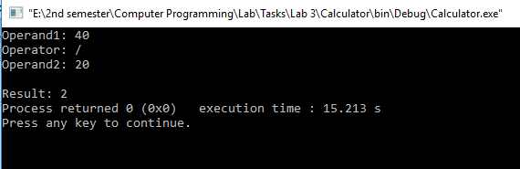

**TASK # 6:**

**Title:**

Write a program that asks a number and test the number whether it is multiple of 5 or not, divisible by 7 but not by eleven. (all three conditions should match).

**Code:**

#include <iostream> /* library for

writing the output to console window*/

using namespace std;

int main()

{

//Variable declaration

int num;

cout << "Enter a number: " << endl;

//Input value of num

cin>>num;

(num%5==0 && num%7==0 && num%11!=0)?cout<<"This is the desired number":cout<<"This

number does not satisfy all the conditions";

return 0;

}

### **Output (Compilation, Debugging & Testing):**

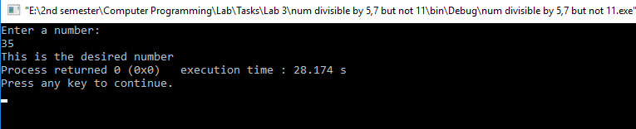

**TASK # 7:**

**Title:**

Write a C++ program to input angles of a triangle and check whether triangle is valid or not.

**Code:**

#include <iostream> /* library for

writing the output to console window*/

using namespace std;

int main()

{

//Variable declaration

int A,B,C;

cout << "Angle 1: ";

//Input value of A

cin>>A;

cout << "Angle 2: ";

//Input value of B

cin>>B;

cout << "Angle 3: ";

//Input value of C

cin>>C;

//Finding whether a triangle is valid or not using ternary operator

((A+B+C)==180)?cout<<"Valid Triangle":cout<<"Invalid Triangle";

return 0;

}

### **Output (Compilation, Debugging & Testing):**

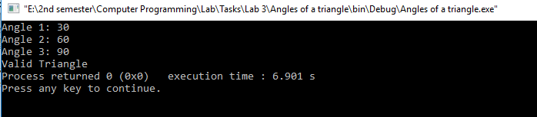**TASK # 8:**

**Title:**

Check whether the entered character is vowel or consonant.

### **Problem Analysis:**

The problem is to Check whether the entered character is vowel or consonant having its inputs parameters identified as: ch (character type). To solve this problem, we use if…else conditional statements. During the processing or calculation phase, we don’t need any extra parameters (variables) for this problem.

**Algorithm:**

1. Start
2. Declare variables: ch (char)
3. Read ch
4. Check whether ch is vowel or not using if statement.
5. Display “The Alphabet you entered is a Vowel” if ch is vowel.
6. Display “The Alphabet you entered is a Consonant” if ch is not vowel.
7. Stop

**Flowchart:**

Stop

Start

Variable declaration:

Ch (char)

Read ch

ch==’A’||ch==’E’||ch==’I’||ch==’O’||ch==’U’

Display”Vowel”

Display “Consonant”

**Code:**

#include <iostream> /* library for

writing the output to console window*/

using namespace std;

int main()

{

char ch;//Variable declaration

cout << "Enter an Alphabet: ";//Display message

cin>>ch;//Input ch

//Check whether ch is vowel or not

if (ch=='A'||ch=='a'||ch=='E'||ch=='e'||ch=='I'||ch=='i'||ch=='O'||ch=='o'||ch=='U'||ch=='u')

cout<<"The Alphabet you entered is a Vowel";//Display message

else

cout<<"The Alphabet you entered is a Consonant"; //Display message

return 0;

}

### **Output (Compilation, Debugging & Testing):**

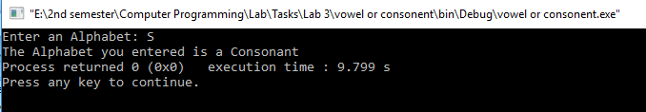

**TASK # 9:**

**Title:**

Write a program to produce the output as shown below:

x y expressions results

6 | 3 | x=y+3 | x=6

6 | 3 | x=y-2 | x=1

6 | 3 | x=y*5 | x=15

6 | 3 | x=x/y | x=2

6 | 3 | x=x%y | x=0

6 | 3 | x=x&y | x=2

6 | 3 | x=x|y | x=7

### **Problem Analysis:**

The problem is to Display the required output.

**Algorithm:**

1. Start
2. Display first line
3. Display second line
4. Display third line
5. Display forth line
6. Display fifth line
7. Display sixth line
8. Display seventh line
9. Display eighth line
10. Stop

**Code:**

#include <iostream> /* library for

writing the output to console window*/

using namespace std;

int main()

{

cout << "\t\tx\t\ty\t\texpressions\t\tresults" << endl; //Display

cout << "\t\t6\t|\t3\t|\tx=y+3 \t|\tx=6" << endl; //Display

cout << "\t\t6\t|\t3\t|\tx=y-2 \t|\tx=1" << endl; //Display

cout << "\t\t6\t|\t3\t|\tx=y*5 \t|\tx=15" << endl; //Display

cout << "\t\t6\t|\t3\t|\tx=x/y \t|\tx=2" << endl; //Display

cout << "\t\t6\t|\t3\t|\tx=x%y \t|\tx=0" << endl; //Display

cout << "\t\t6\t|\t3\t|\tx=x&y \t|\tx=2" << endl;//Display

cout << "\t\t6\t|\t3\t|\tx=x|y \t|\tx=7" << endl; //Display

return 0;

}

**Flowchart:**

Start

Display line 1

Display line 2

Display line 3

Display line 4

Display line 5

Display line 6

Display line 7

Display line 8

Stop

### **Output (Compilation, Debugging & Testing):**

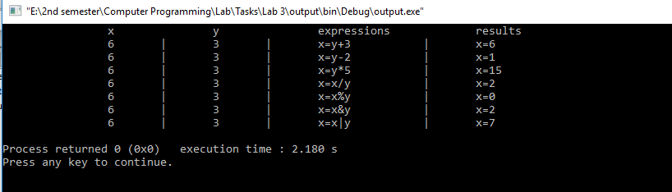

**TASK # 10:**

**Title:**

Write a program that takes the week day number as input from user and print the day name of week.

E.g., Print Monday if week day number is equal to 1. Similarly, check condition for all 7 days and print the corresponding day name. Print an error message if an invalid number is entered.

### **Problem Analysis:**

The problem is to Display the day name of the week having its inputs parameters identified as: A (integer type). To solve this problem, we use if…else conditional statements. During the processing or calculation phase, we don’t need any extra parameters (variables) for this problem.

**Algorithm:**

1. Start
2. Variable declaration: A(int)
3. Read A
4. Display “Monday” if A is equal to 1
5. Display “Tuesday” if A is equal to 2
6. Display “Wednesday” if A is equal to 3
7. Display “Thursday” if A is equal to 4
8. Display “Friday” if A is equal to 5
9. Display “Saturday” if A is equal to 6
10. Display “Sunday” if A is equal to 7
11. Display “Invalid entry” if other numbers are entered
12. Stop.

**Flowchart:**

Start

Stop

Variable declaration: A(int)

Read A

A==1

A==2

A==3

A==4

A==5

A==6

A==7

Display”First Day of a week is Monday”

Display”Second Day of a week is Tuesday”

Display”Third Day of a week is Wednesday”

Display”Forth Day of a week is Thursday”

Display”Fifth Day of a week is Friday”

Display”Sixth Day of a week is Saturday”

Display”Seventh Day of a week is Sunday”

Display”Invalid Day Number entered”

**Code:**

#include <iostream>

using namespace std;

int main()

{

int A; //Variable declaration

cout << "Enter the Day number: "; //Display message

cin>>A; //Input A

if(A==1) //When A is equal to 1

cout<<"First Day of a week is Monday"; //Display message

else if(A==2) //When A is equal to 2

cout<<"Second Day of a week is Tuesday"; //Display message

else if(A==3) //When A is equal to 3

cout<<"Third Day of a week is Wednesday"; //Display message

else if(A==4) //When A is equal to 4

cout<<"Forth Day of a week is Thursday"; //Display message

else if(A==5) //When A is equal to 5

cout<<"Fifth Day of a week is Friday"; //Display message

else if(A==6) //When A is equal to 6

cout<<"Sixth Day of a week is Saturday"; //Display message

else if(A==7) //When A is equal to 7

cout<<"Seventh Day of a week is Sunday"; //Display message

else

cout<<"Invalid Day number entered!!!"; //Display message

return 0;

}

### **Output (Compilation, Debugging & Testing):**

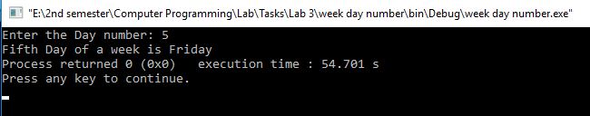

**TASK # 11:**

**Title:**

Write a C++ program to enter month number between (1-12) and print number of days in month.

### **Problem Analysis:**

The problem is to Display the number of days in a month having its inputs parameters identified as: num (integer type). To solve this problem, we use if…else conditional statements. During the processing or calculation phase, we don’t need any extra parameters (variables) for this problem.

**Algorithm:**

1. Start
2. Declare variables: num (int)
3. Display “Number of Days: 28 or 29” if num is equal to 2.
4. Display “Number of Days: 30” if num is less than 8 and num mod 2 is equal to 0.
5. Else Display” Number of Days: 31”.
6. Display “Number of Days: 31” if num is less than 13 and num mod 2 is equal to 0.
7. Else Display” Number of Days: 30”.
8. Stop

**Flowchart:**

Display” Invalid Entry”

Display” Number of Days: 30”

Display” Number of Days: 31”

Display” Number of Days: 31”

num&2==0

num<13

Display” Number of Days: 30”

Display” Number of Days: 28 or 29”

num%2==0

Stop

num==2

num<8

Read num

Variable declaration: int num

Start

**Code:**

#include <iostream>

using namespace std;

int main()

{

int num; //variable declaration

cout << "Enter the Month number: ";

cin>>num; //input num

if(num<8) //check condition

{

if(num==2) //check condition

cout<<"Number of Days: 28 or 29"; //Display message

else if(num%2==0) //check condition

cout<<"Number of Days: 30"; //Display message

else

cout<<"Number of Days: 31"; //Display message

}

else if(num<13) //check condition

{

if(num%2==0) //check condition

cout<<"Number of Days: 31"; //Display message

else

cout<<"Number of Days: 30"; //Display message

}

else

cout<<"Invalid Number of Month Entered!!!"; //Display message

return 0;

}

### **Output (Compilation, Debugging & Testing):**

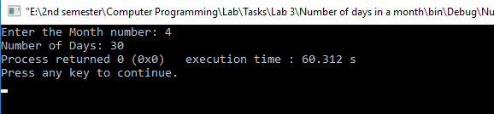**TASK # 12:**

**Title:**

Write a program to calculate and print the Electricity bill of a given customer. The customer id and unit consumed by the user should be taken from the keyboard and display the total amount to pay to the customer. The charges are as follow :

|  |  |
| --- | --- |
| **Unit** | **Charge/unit** |
| upto 199 | @1.20 |
| 200 and above but less than 400 | @1.50 |
| 400 and above but less than 600 | @1.80 |
| 600 and above | @2.00 |

If bill exceeds Rs. 400 then a surcharge of 15% will be charged and the minimum bill should be of Rs. 100/-

**Test Data:**

1001

800

**Expected Output:**

Customer IDNO: 1001

Units Consumed: 800

Amount Charges @Rs. 2.00 per unit: 1600.00

Surchage Amount : 240.00

Net Amount Paid By the Customer : 1840.00

### **Problem Analysis:**

The problem is to Display the electricity bill of a customer having its inputs parameters identified as: ID (integer type) and UC (integer type). To solve this problem, we use if…else conditional statements. During the processing or calculation phase, we don’t need any extra parameters (variables) for this problem.

**Code:**

#include <iostream>

using namespace std;

int main()

{

int UC,ID;

float AC,SA,NA;

cout << "Customer IDNO: ";

cin>>ID;

cout << "Units Consumed: ";

cin>>UC;

if(UC<200)

{

AC=UC*1.20;SA=0;NA=AC+SA;

cout<<"Amount Charges @Rs. 1.20 per unit: "<<AC<<endl;

cout<<"Surcharge Amount : "<<SA<<endl;

cout<<"Net Amount Paid By the Customer : "<<NA;

}

else if(UC<400)

{

AC=UC*1.50;SA=0;NA=AC+SA;

cout<<"Amount Charges @Rs. 1.50 per unit: "<<AC<<endl;

cout<<"Surchage Amount : "<<SA<<endl;

cout<<"Net Amount Paid By the Customer : "<<NA;

}

else if(UC<600)

{

AC=UC*1.80;SA=(AC*15)/100;NA=AC+SA;

cout<<"Amount Charges @Rs. 1.80 per unit: "<<AC<<endl;

cout<<"Surchage Amount : "<<SA<<endl;

cout<<"Net Amount Paid By the Customer : "<<NA;

}

else

{

AC=UC*2.00;SA=(AC*15)/100;NA=AC+SA;

cout<<"Amount Charges @Rs. 2.00 per unit: "<<AC<<endl;

cout<<"Surchage Amount : "<<SA<<endl;

cout<<"Net Amount Paid By the Customer : "<<NA;

}

return 0;

}

**Output (Compilation, Debugging & Testing):**

